**BOOK RECOMMENDATION INFORMATION SYSTEM**

**Prepared by: Blessed Njeri**

**ADM NO:41489**

**Supervisor Name: Mr. Mburu**

# CHAPTER ONE

## 1.0 Introduction

The Book Recommendation Information System is designed to help users discover books that match their interests, preferences, and reading history. It leverages data-driven algorithms to recommend books and enhance user satisfaction in reading experiences.

## 1.1 Problem Statement

Despite the growing number of digital libraries and e-commerce platforms, readers still face challenges in finding books tailored to their preferences. Existing systems often lack personalization, expose readers to irrelevant options, and fail to bridge the gap between user expectations and accurate recommendations.

## 1.2 Objectives

**General Objective:**  
To design and develop an information system that recommends books to users based on their preferences, reading history, and ratings.

**Specific Objectives:**  
1. To provide administrators with tools to add, update, or remove books and manage user accounts.

2.To provide an intuitive and user-friendly interface for exploring recommended books.  
3. To generate usage and recommendation reports for analysis and decision-making.

4. To enable users to rate, review, and give feedback on books.

## 1.3 Justification

The system will benefit readers by providing relevant book suggestions, improving the reading experience, and saving time in book discovery. The scope of the system includes book recommendation, preference analysis, and user interaction through an online platform.

# CHAPTER TWO

## 2.0 System Overview

This chapter will examine real-world systems to show current practices, challenges, and how a proposed system can provide better solutions. The focus is on the **Amazon Book Recommendation System**, **Goodreads Suggestion Engine**, and **Google Books Recommendation System**, which use data-driven technology to recommend books to readers. These systems help users discover new books based on preferences, ratings, and reading history. However, they still face challenges such as limited personalization, biased recommendations, and data privacy concerns. Studying these systems highlights opportunities for improving accuracy, user satisfaction, and fairness in automated book recommendation processes.

**2.0 CASE STUDY 1: Amazon Book Recommendation system** analyzes user behavior, purchase history, ratings and browsing patterns to suggest books tailored to each reader’s interests.

|  |  |
| --- | --- |
| **strengths** | **weaknesses** |
| Finds similarities between users to suggest book with similar interests. | Struggles to recommend accurately for new users/new books with little data. |
| Improves over time as more data is collected and analyzed | Inaccurate/missing ratings and reviews can reduce recommendation quality |
| Increased sales and engagement | Heavy reliance on user data can raise privacy and security issues. |

**2.1 CASE STUDY 2: Goodreads Suggestion Engine** combines collaborative filtering and content-based algorithms to personalize book suggestions, helping readers discover new titles that match their interests and reading preferences.

|  |  |
| --- | --- |
| **strengths** | **weaknesses** |
| Continuous improvement of suggestions through user ratings and reviews. | Updates to recommendation may not immediately reflect recent user activity. |
| Access to massive collection of books across genres and authors. | New users with little activity receive less accurate recommendations. |
| Allows users to enhance engagement and social integration. | Dependence on user engagement |

**2.2 CASE STUDY:3 Google Books Recommendation system** uses machine learning and natural language processing to analyze user research, reading patterns and book content.

|  |  |
| --- | --- |
| **strengths** | **weaknesses** |
| Advanced machine learning | Limited social interactions. |
| Access to massive global database of books including academic rare and titles. | Relies on personal search and reading data which may raise user privacy issues. |

## 2.3 Existing Gaps

Many current systems do not provide highly personalized recommendations, often suggesting general books that may not match user interests. Feedback options like ratings and reviews are not always well integrated, affecting the accuracy of future suggestions.

# CHAPTER THREE

## 3.0 Design Phase

### 3.1 Logical Design

The logical design includes the Entity Relationship Diagram (ERD) and flowcharts to represent how data flows through the system and how entities relate to one another.

### 3.1.1 Entity Relationship Diagram (ERD)

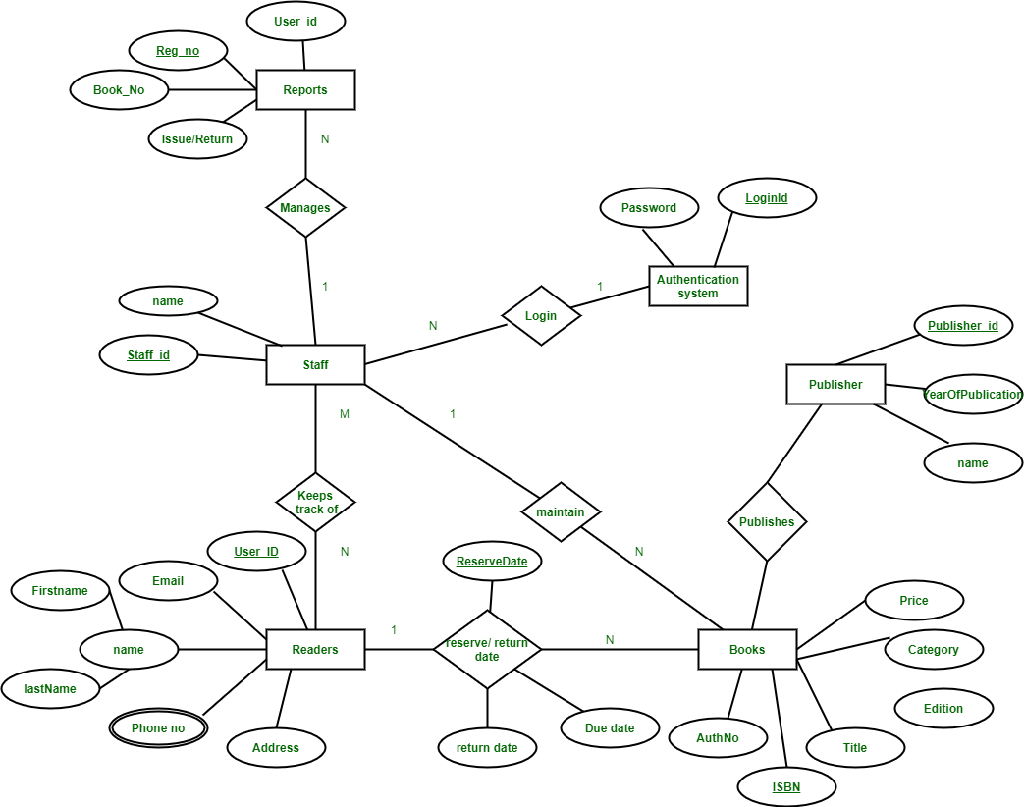 figure 1:

### 3.12 Physical Design

The physical design defines normalized tables, data types, and their relationships. Wireframes are used to illustrate the interface design and user navigation across the system.

### 3.1.1 Flowcharts

[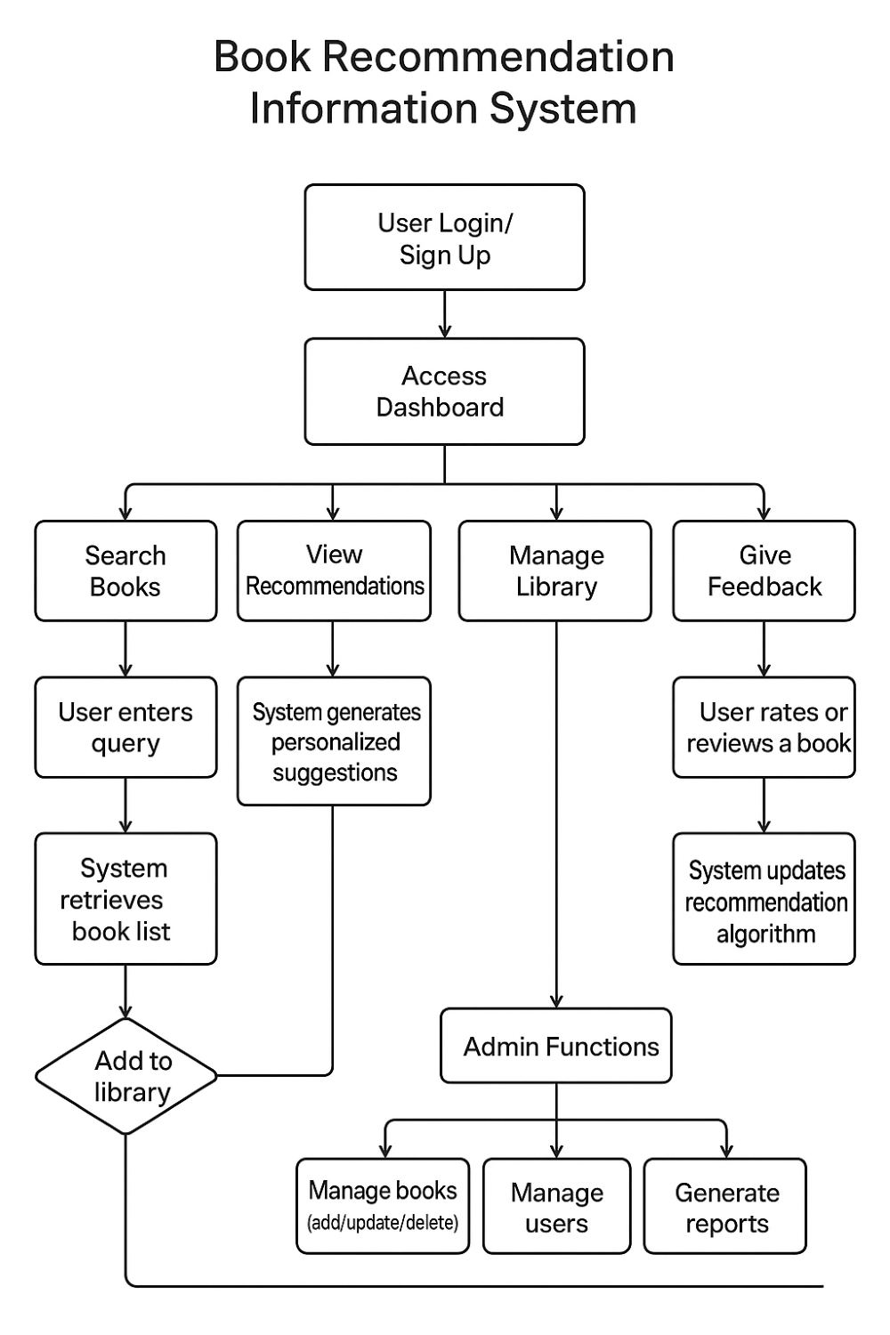 figure 2:

### 3.2.1 Normalized Table

Below are the key tables and their attributes.

**Users** (user-ID, UserName, Email)

**Books** (BookID, Title, Genre, PublisherID)

**Publishers** (PublisherID, PulisherName)

**Authors** (AuthorID, AuthorName)

**Ratings** (RatingsID, UserID, BookID, Rating, review text)

**Recommendations** (Rec-ID, UserID, Book_ID, score, recommended date)

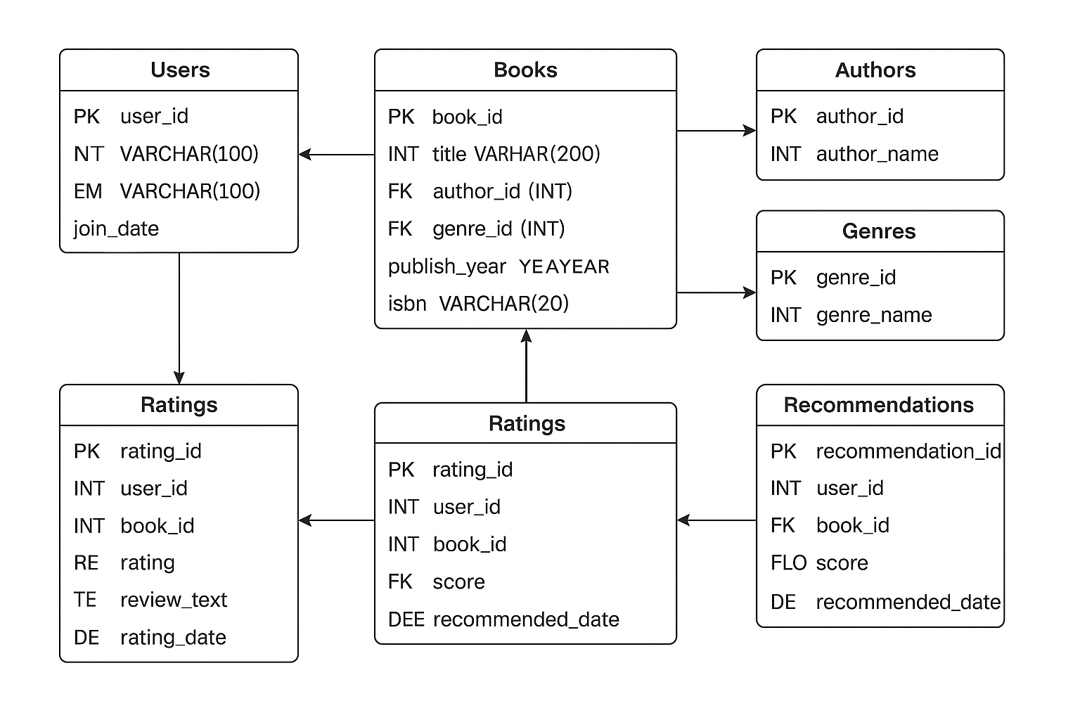 figure 3:

### 3.2.2 Wireframes

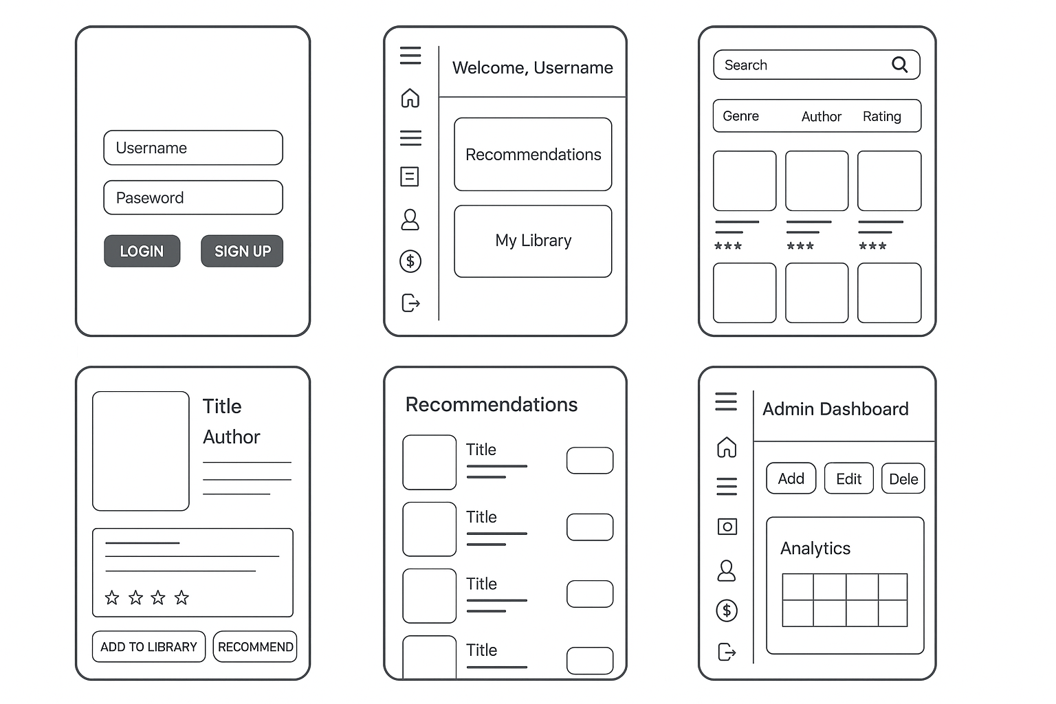figure 4: